DSI Exercise 03:

**Assignment 1: Apply Discretization**

Discretize the attribute “Overall rank” into the Top 10, Top 11-50, and Top 51-100 of the happiest countries in the world in 2019. Leave all other attributes as is (you can apply settings to a selection of attributes at once). Look at the results and compare it to the original data set (you can use the “Data Table” widget for that). Then use the “Select Rows” widget to select the Top 10 and look at the re- sults. Make screenshots of the complete workflow, the discretization settings, and the resulting data.

Answer:

The screen shots are given below:

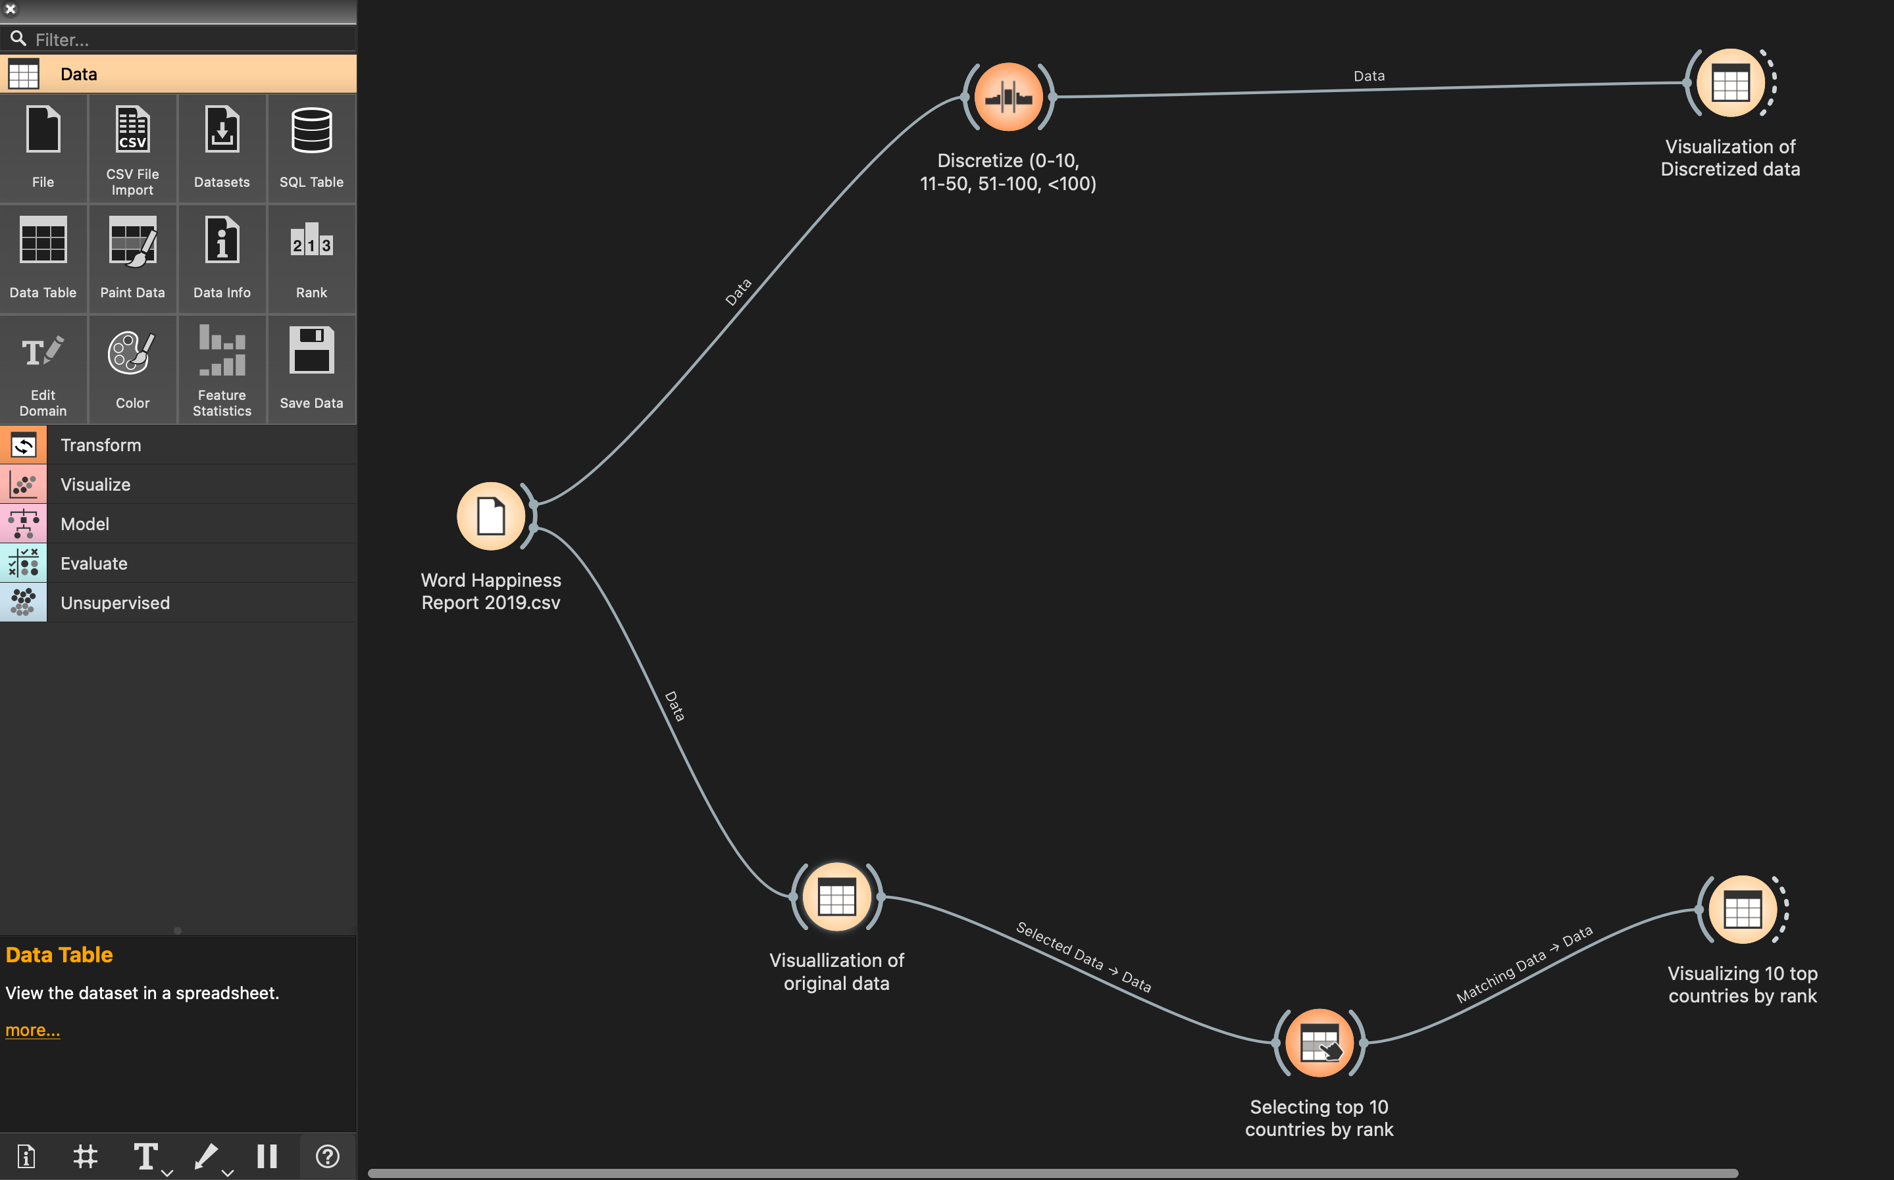

Figure 1Complete workflow of discretizing 'Overall rank' attribute

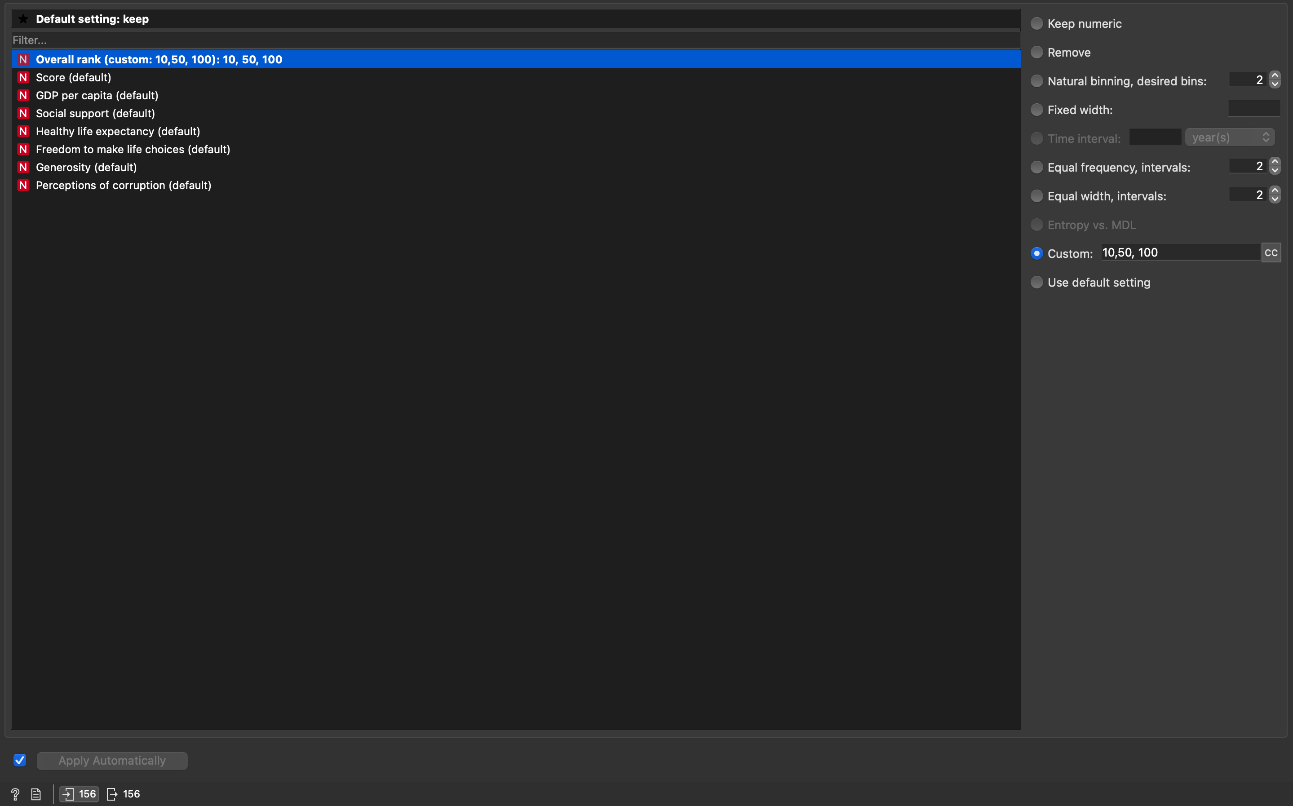

Figure 2 Discretization settings

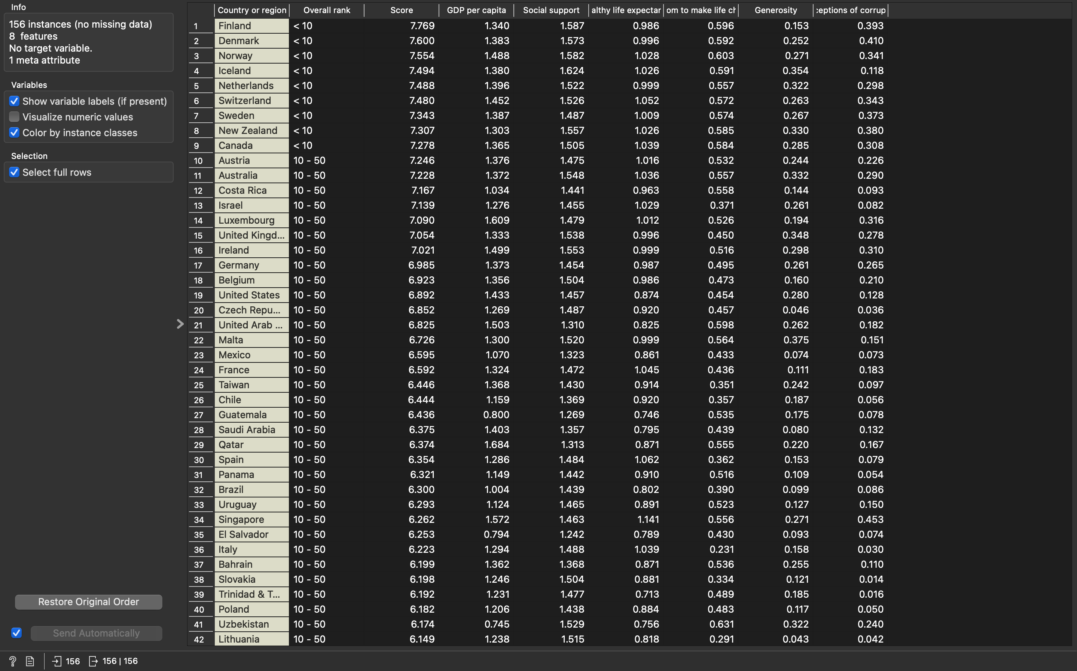

Figure 3 Full resulting data after discretization

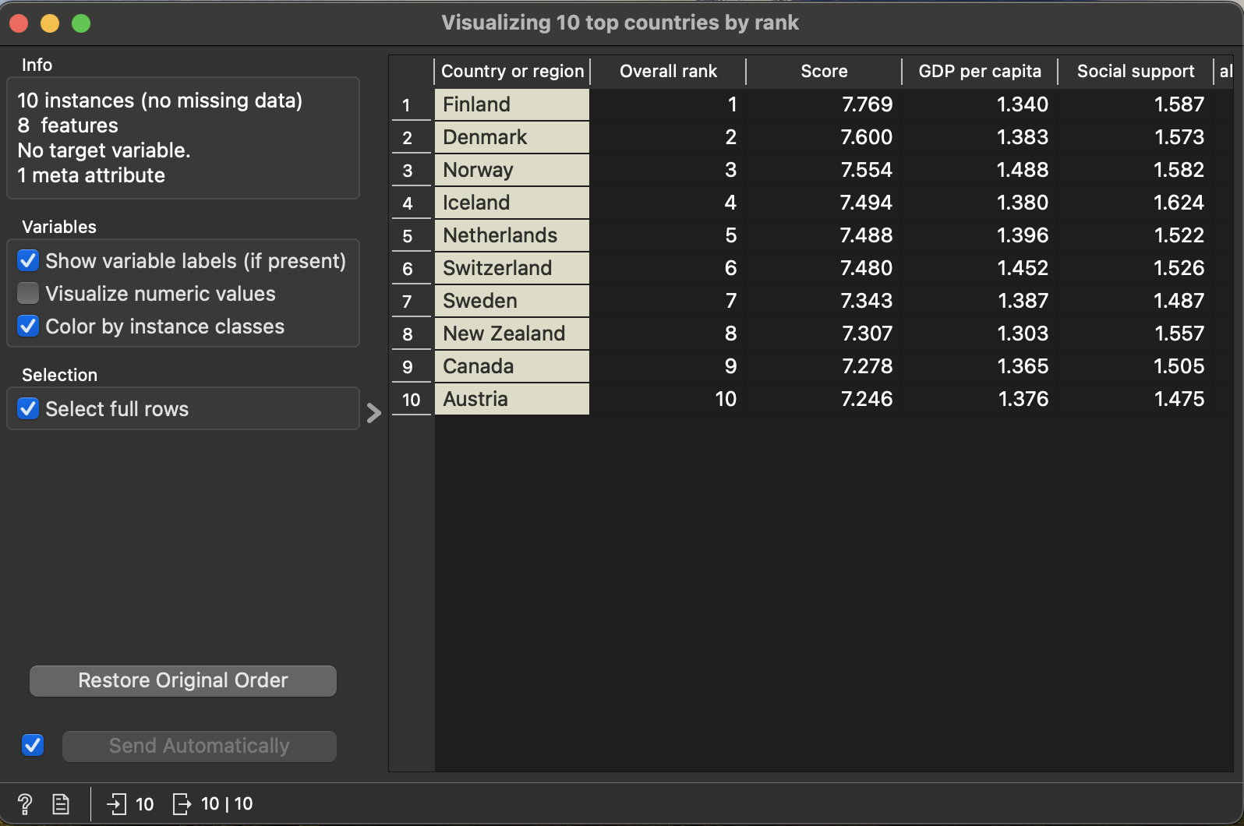

Figure 4 Top 10 countries by 'Overall rank'

**Assignment 2: Pre-processing of Text Data**

1. First, remove all preprocessing steps except “Transformation” and transform the corpus into lowercase. This avoids to have multiple versions (“Large” and “large”) of the same word. If you checked the box “Apply Automatically” on the lower left, the changes are directly ap- plied. You can use the “Word Cloud” widget to observe the effect of the transformation. Please note that also punctuation symbols are also counted. Save the word cloud clicking on the disk symbol.

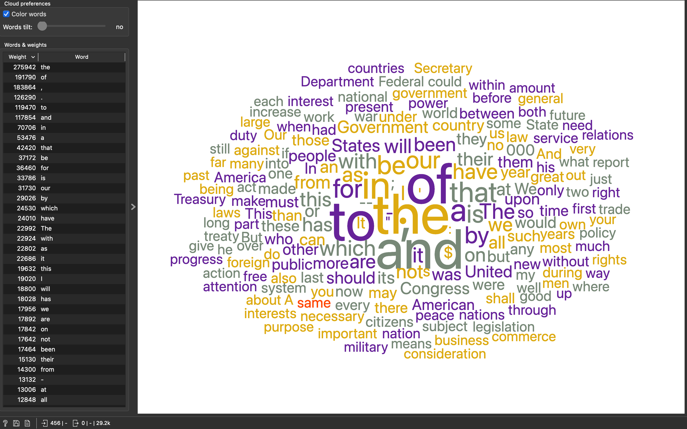

Figure 5 Original Word Cloud

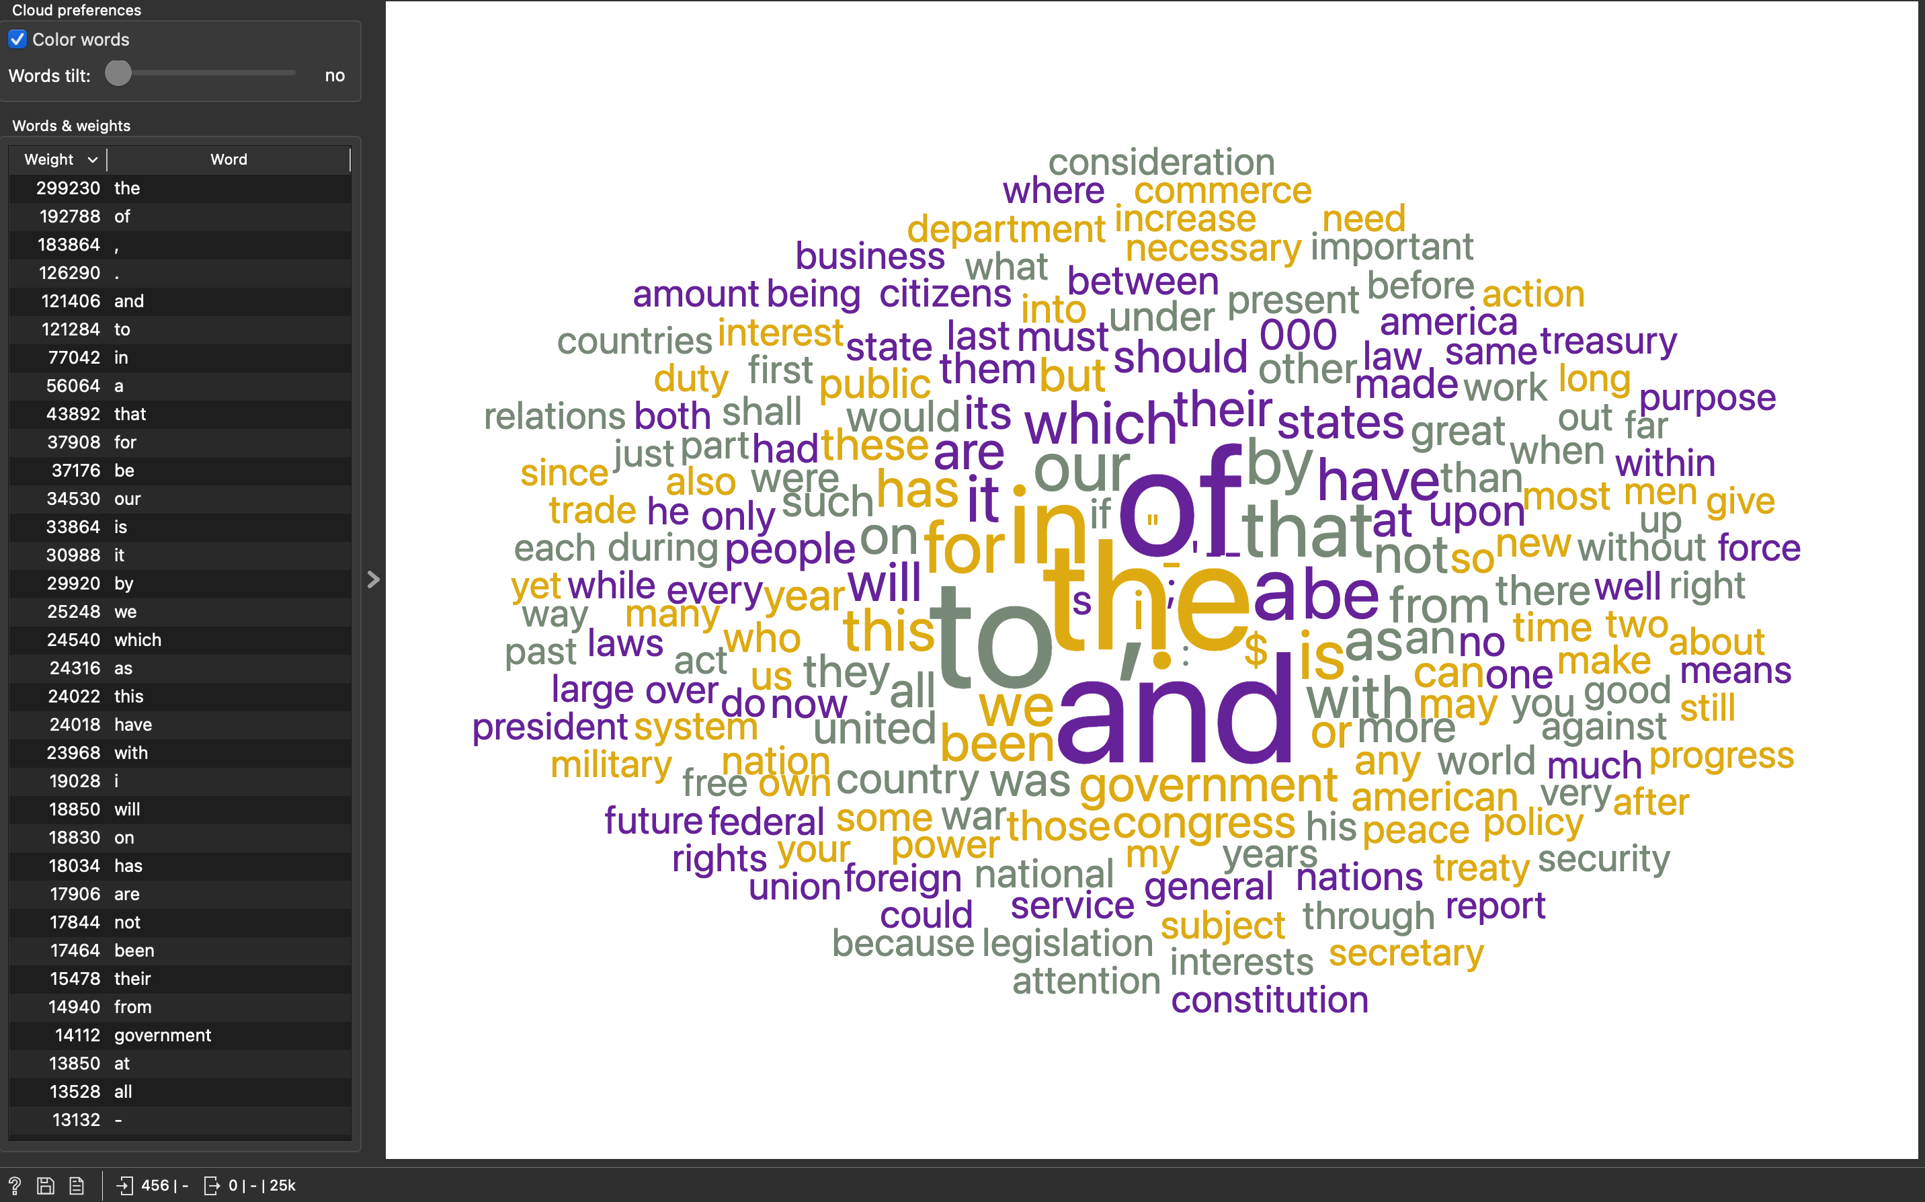

Figure 6 After 'Transformation' to lowercase

1. Now apply “Tokenization”. This is used to break the text into smaller pieces like sentences, words, ... Please have a look at the aforementioned documentation to understand the differ- ent tokenization methods. Use Regular Expressions to split the text by words without keep- ing punctuation. This is quite a common way to break down text. What are the top 3 words? Save the word cloud clicking on the disk symbol.

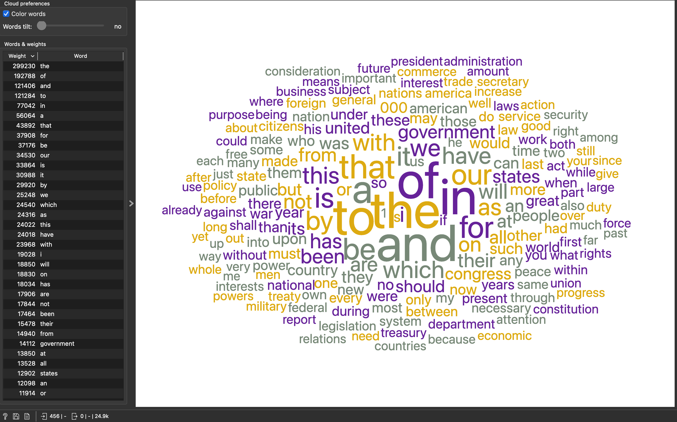

Figure 7 After tokenization

Fromt the image, we can see that ‘the’, ‘of’, and ‘and’ are the top three words.

1. Now filter the stopwords. What are the top 3 words now? Save the word cloud clicking on the disk symbol.

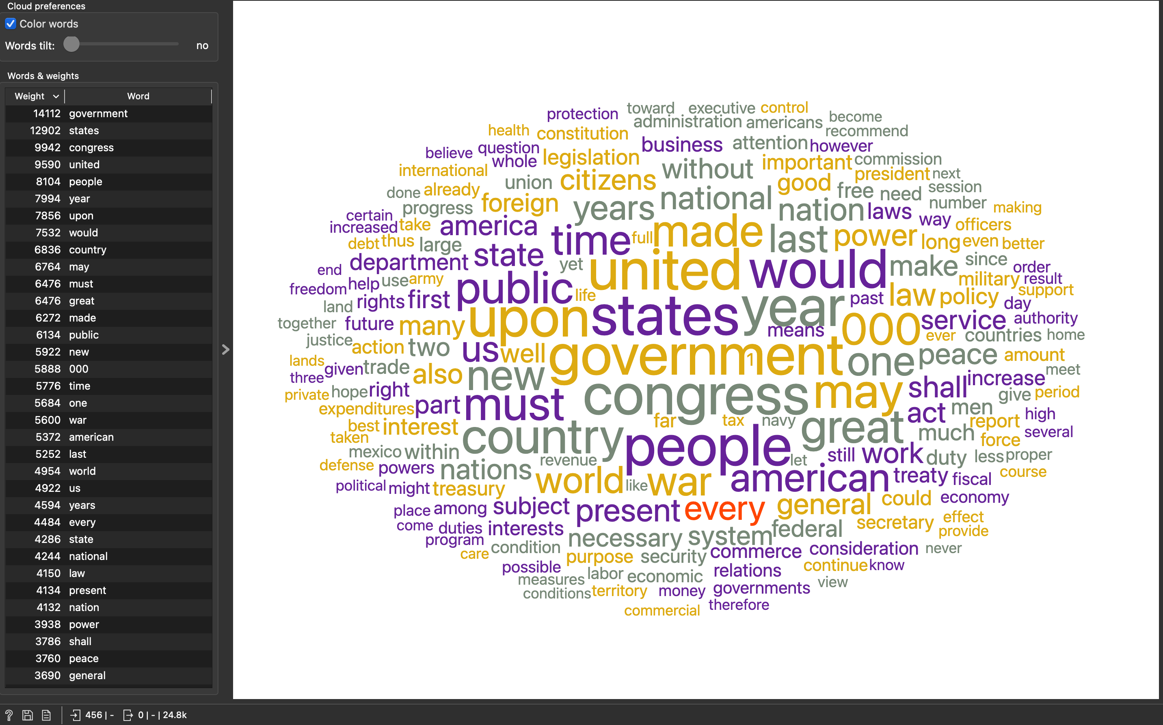

Figure 8 After filtering the stopwords.

After filtering, we can see that the ‘government’, ‘states’, and ‘congress’ are the top three words.

1. Apply the standard normalization (Porter Stemmer). This does, to put it simple, convert words to their base form, like e.g. “the boy's cars are different colors” à “the boy car be differ color”. What do you observe?

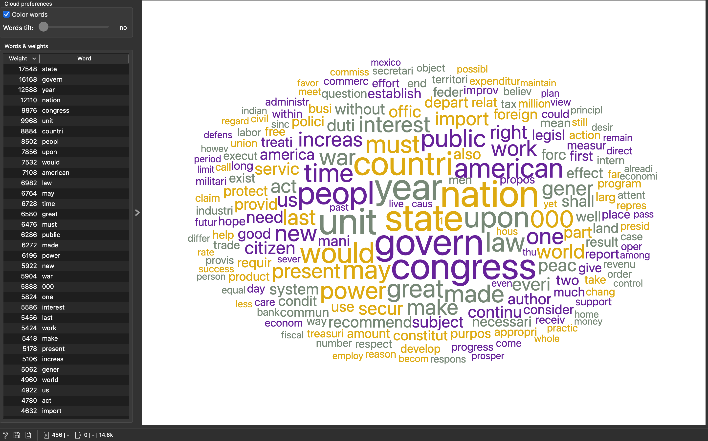

Figure 9 After normalization

After applying standard normalization (Porter Stemmer), we can see that the ‘state’, ‘govern’, and ‘year’ are the top three words. Before normalization, there was a full word ‘government’ in the top position. However, after normalization, it drops down to second position and only base form ‘govern’ is remained.

The complete workflow and preprocessing settings are also shown below.

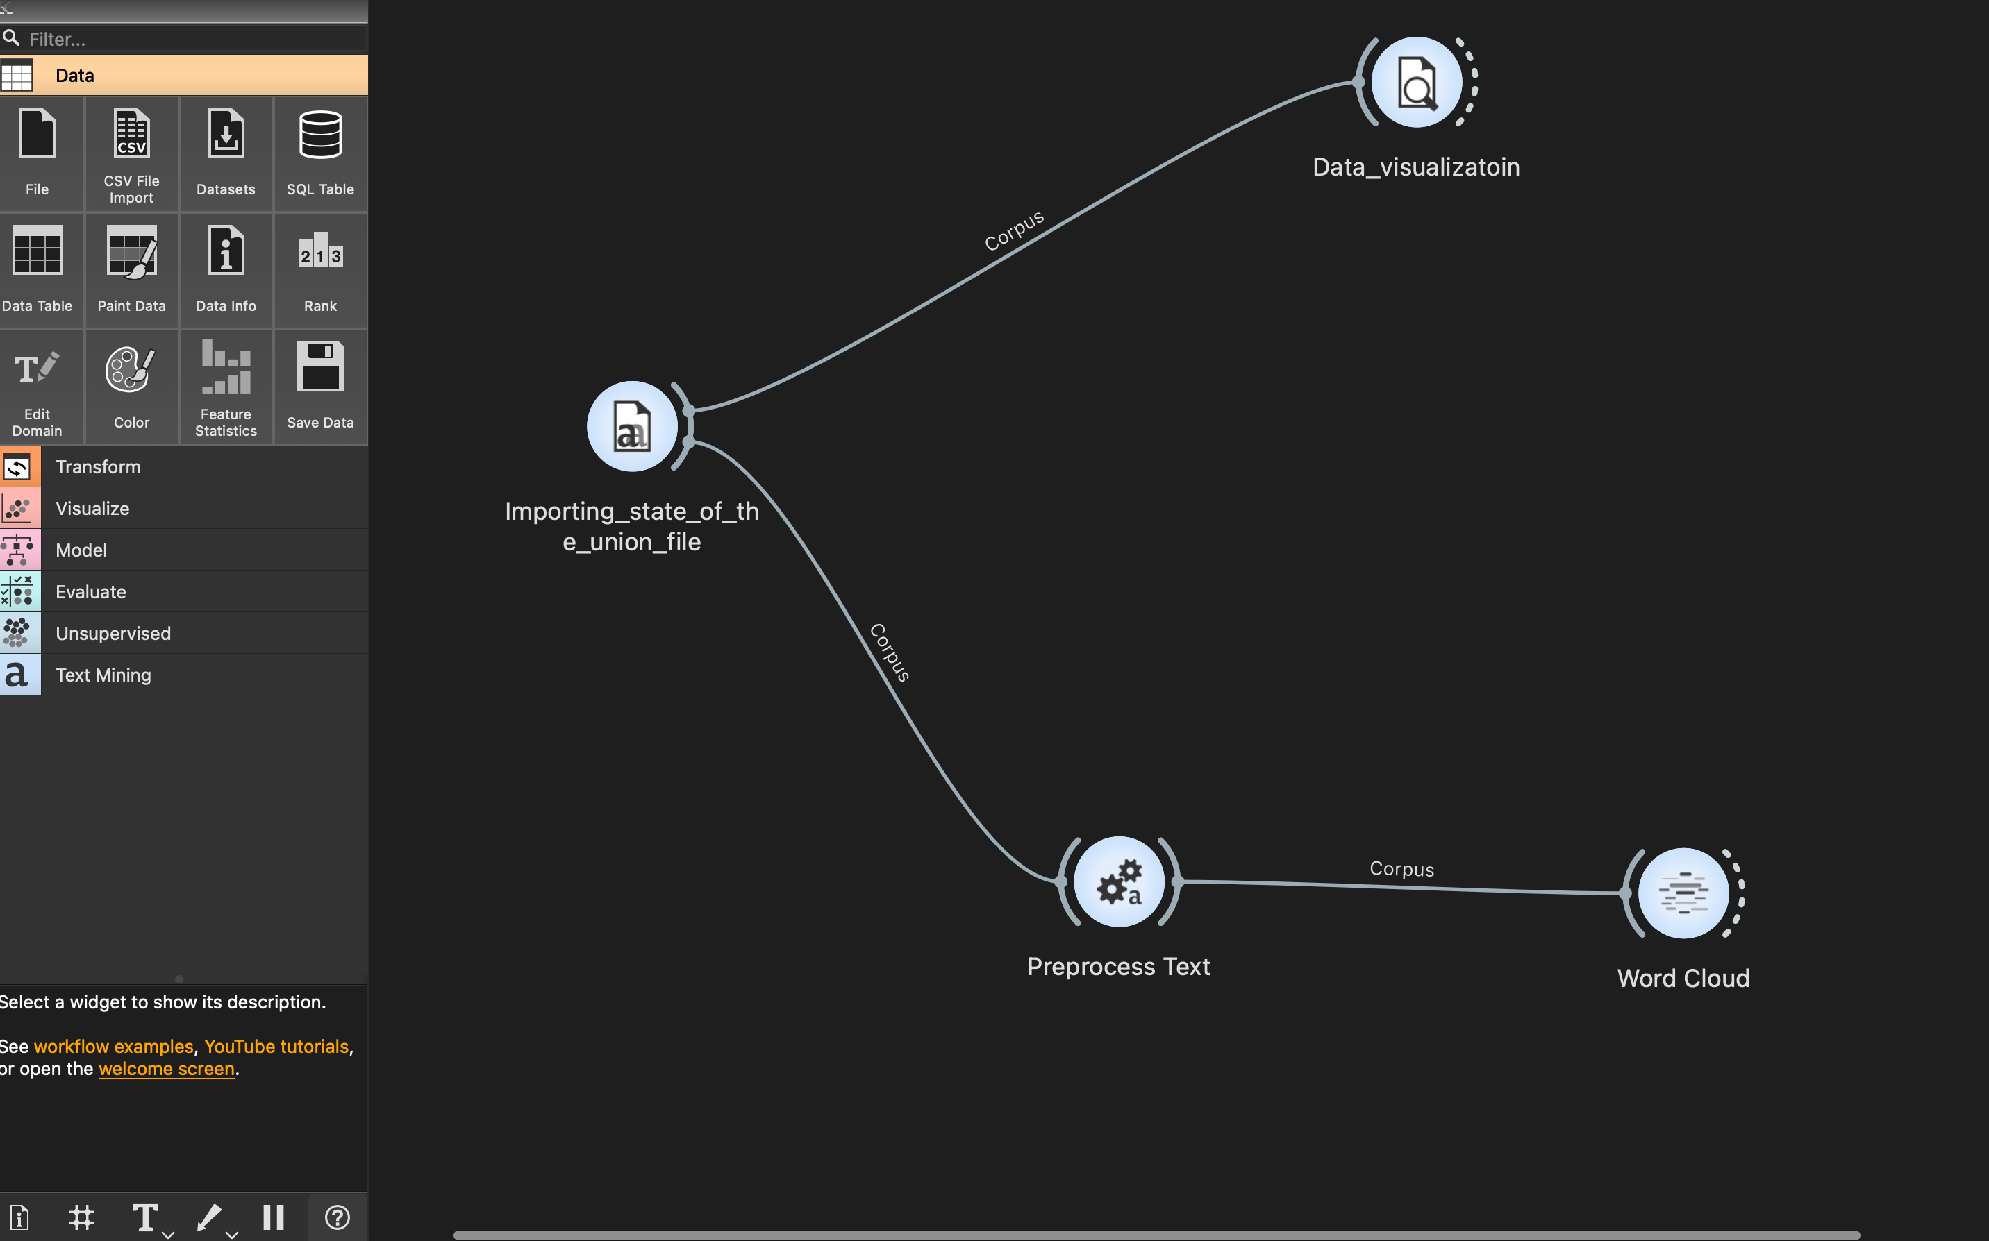

Figure 10 Complete workflow

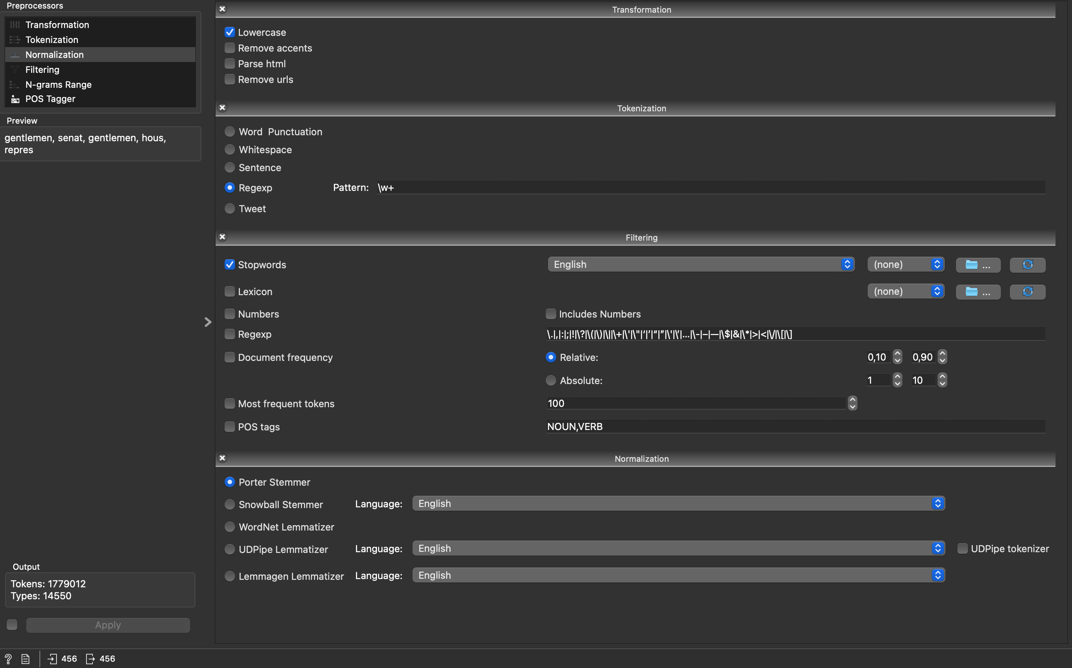

Figure 11 Preprocessing steps and settings